AI ASSISTED CODING
ASSIGNMENT-3.4_1557
NAME:T.TEJASRI
HT NO:2303A51557
BATCH:09

#generate a python code to automate its daily billing process for a retail store
def calculate_bill(items):
total = 0
for item, price in items.items():
total += price
return total
items = {}
n = int(input("Enter number of items purchased: "))
for _ in range(n):
item_name = input("Enter item name: ")
item_price = float(input("Enter item price: "))
items[item_name] = item_price
total_bill = calculate_bill(items)
print("Total bill amount: $", total_bill)
#develop a console based application that assist the cashier in generating customer bills
def generate_bill():
items = {}
n = int(input("Enter number of items purchased: "))
for _ in range(n):
item_name = input("Enter item name: ")
item_price = float(input("Enter item price: "))
items[item_name] = item_price
total = sum(items.values())
print("\n--- Customer Bill ---")
for item, price in items.items():
print(f"{item}: ${price:.2f}")
print(f"Total Amount: ${total:.2f}")
generate_bill()
#the program should accept customers name ,the number of items purchased, price of each item
def customer_bill():
customer_name = input("Enter customer name: ")
items = {}
n = int(input("Enter number of items purchased: "))
for _ in range(n):
item_name = input("Enter item name: ")
item_price = float(input("Enter item price: "))
items[item_name] = item_price
total = sum(items.values())
print(f"\n--- Bill for {customer_name} ---")
for item, price in items.items():
print(f"{item}: ${price:.2f}")
print(f"Total Amount: ${total:.2f}")
customer_bill()
#it should calculate the total bill amount and apply a discount based on total purchase value
def customer_bill_with_discount():
customer_name = input("Enter customer name: ")
items = {}
n = int(input("Enter number of items purchased: "))
for _ in range(n):
item_name = input("Enter item name: ")
item_price = float(input("Enter item price: "))
items[item_name] = item_price
total = sum(items.values())
discount = 0
if total > 100:
discount = total * 0.1 # 10% discount for bills over $100
final_total = total - discount
print(f"\n--- Bill for {customer_name} ---")
for item, price in items.items():
print(f"{item}: ${price:.2f}")
print(f"Subtotal: ${total:.2f}")
print(f"Discount: ${discount:.2f}")
print(f"Total Amount after discount: ${final_total:.2f}")
customer_bill_with_discount()
#the program must also cacalculate tax on the discounted amount and display the final payable bill clearly
def customer_bill_with_discount_and_tax():
customer_name = input("Enter customer name: ")
items = {}
n = int(input("Enter number of items purchased: "))
for _ in range(n):
item_name = input("Enter item name: ")
item_price = float(input("Enter item price: "))
items[item_name] = item_price
total = sum(items.values())
discount = 0
if total > 100:
discount = total * 0.1 # 10% discount for bills over $100
discounted_total = total - discount
tax = discounted_total * 0.07 # 7% tax
final_total = discounted_total + tax
print(f"\n--- Bill for {customer_name} ---")
for item, price in items.items():
print(f"{item}: ${price:.2f}")
print(f"Subtotal: ${total:.2f}")
print(f"Discount: ${discount:.2f}")
print(f"Total after discount: ${discounted_total:.2f}")
print(f"Tax: ${tax:.2f}")
print(f"Final Amount Payable: ${final_total:.2f}")
customer_bill_with_discount_and_tax()
#the system should allow the cashier to generate bills for multiple customers until they choose to stop the program
def billing_system():
while True:
customer_name = input("Enter customer name: ")
items = {}
n = int(input("Enter number of items purchased: "))
for _ in range(n):
item_name = input("Enter item name: ")
item_price = float(input("Enter item price: "))
items[item_name] = item_price
total = sum(items.values())
discount = 0
if total > 100:
discount = total * 0.1 # 10% discount for bills over $100
discounted_total = total - discount
tax = discounted_total * 0.07 # 7% tax
final_total = discounted_total + tax
print(f"\n--- Bill for {customer_name} ---")
for item, price in items.items():
print(f"{item}: ${price:.2f}")
print(f"Subtotal: ${total:.2f}")
print(f"Discount: ${discount:.2f}")
print(f"Total after discount: ${discounted_total:.2f}")
print(f"Tax: ${tax:.2f}")
print(f"Final Amount Payable: ${final_total:.2f}")

cont = input("Do you want to generate bill for another customer? (yes/no): ")
if cont.lower() != 'yes':
break
billing_system()

OUTPUT:
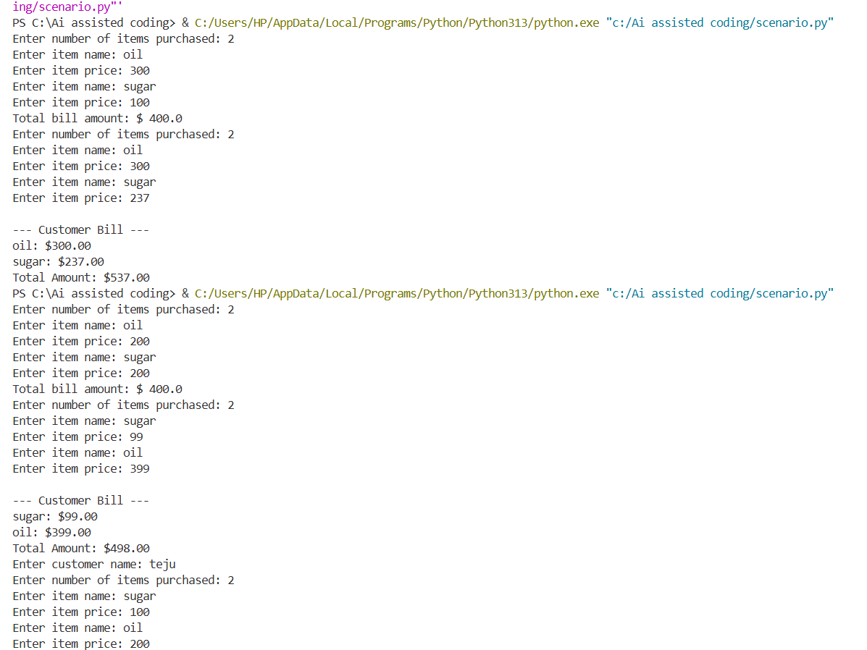
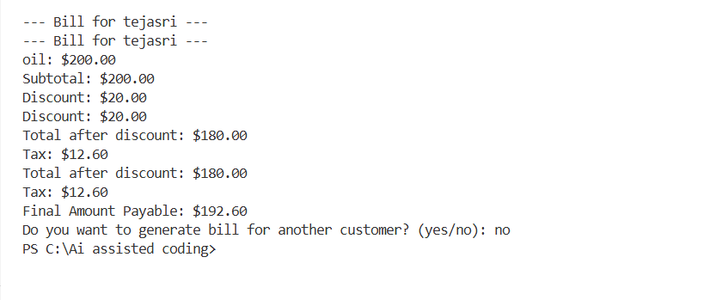
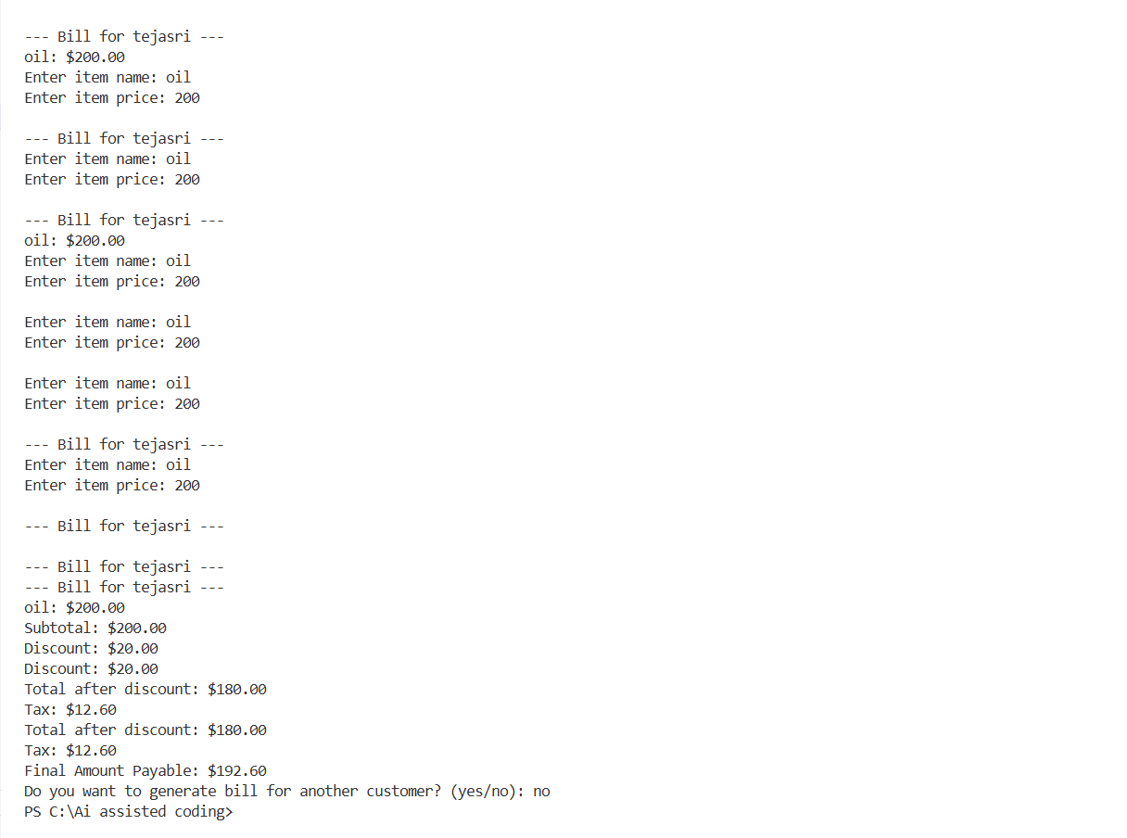
#task-01:Zero shot prompt-Fibbonocci series
#write a python function to print the first n fibonocci numbers
def fibonacci(n):
a, b = 0, 1
fib_sequence = []
for _ in range(n):
fib_sequence.append(a)
a, b = b, a + b
return fib_sequence
n = int(input("Enter the number of terms: "))
print("Fibonacci series:", fibonacci(n))
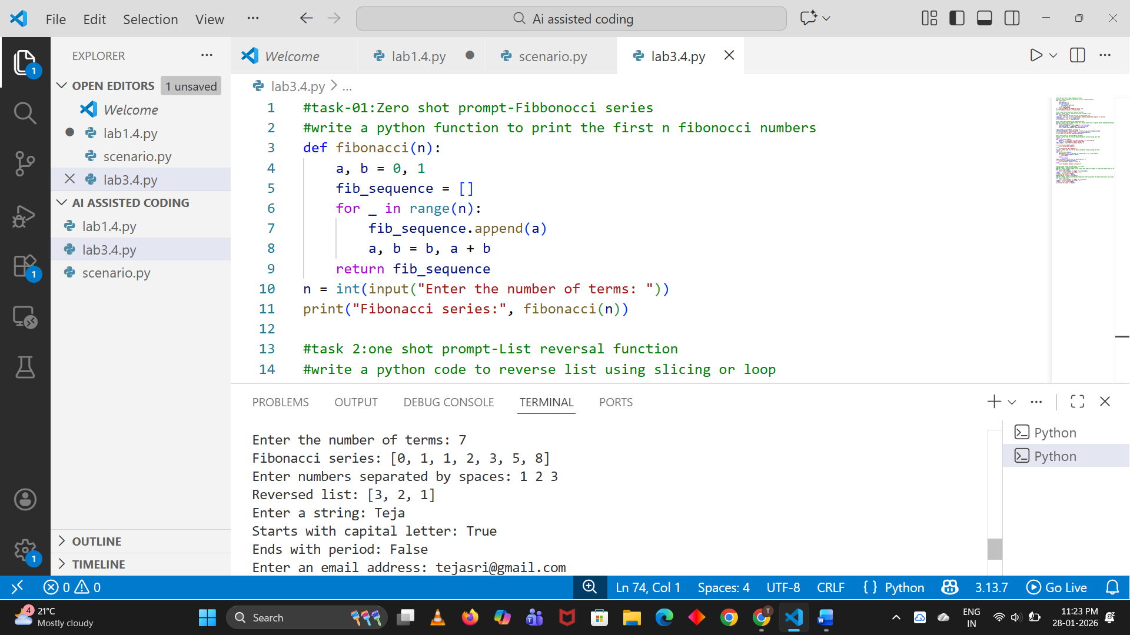

#task 2:one shot prompt-List reversal function
#write a python code to reverse list using slicing or loop
def reverse_list(lst):
return lst[::-1] # Using slicing to reverse the list
input_list = [int(x) for x in input("Enter numbers separated by spaces: ").split()]
reversed_list = reverse_list(input_list)
print("Reversed list:", reversed_list)
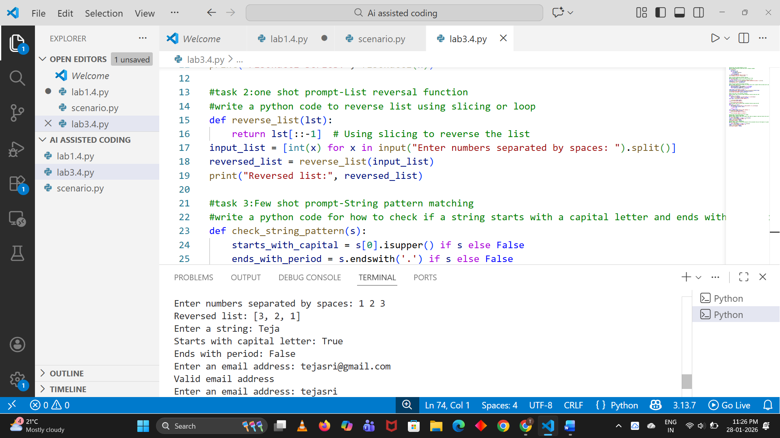

#task 3:Few shot prompt-String pattern matching
#write a python code for how to check if a string starts with a capital letter and ends with a period
def check_string_pattern(s):
starts_with_capital = s[0].isupper() if s else False
ends_with_period = s.endswith('.') if s else False
return starts_with_capital, ends_with_period
input_string = input("Enter a string: ")
starts_with_capital, ends_with_period = check_string_pattern(input_string)
print(f"Starts with capital letter: {starts_with_capital}")
print(f"Ends with period: {ends_with_period}")
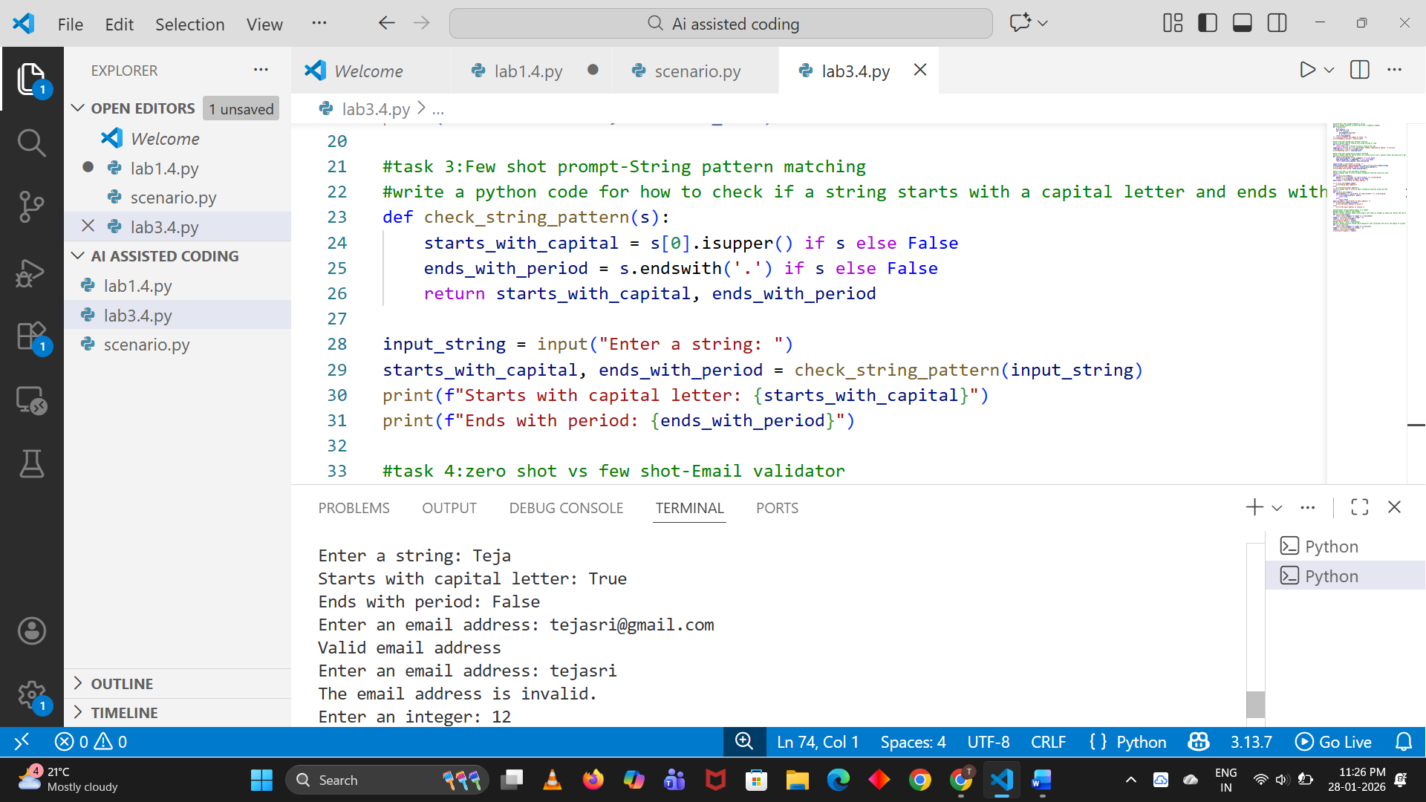

#task 4:zero shot vs few shot-Email validator
#write a python code to write an email validation function using zero shot
import re
def is_valid_email(email):
pattern = r'^[a-zA-Z0-9._%+-]+@[a-zA-Z0-9.-]+\.[a-zA-Z]{2,}$'
return re.match(pattern, email) is not None
email_input = input("Enter an email address: ")
if is_valid_email(email_input):
print("Valid email address")
else:
print("Invalid email address")
#write a python code to write an email validation function using few shot
import re
def validate_email(email):
email_pattern = r'^[a-zA-Z0-9._%+-]+@[a-zA-Z0-9.-]+\.[a-zA-Z]{2,}$'
if re.match(email_pattern, email):
return True
else:
return False
email_to_check = input("Enter an email address: ")
if validate_email(email_to_check):
print("The email address is valid.")
else:
print("The email address is invalid.")
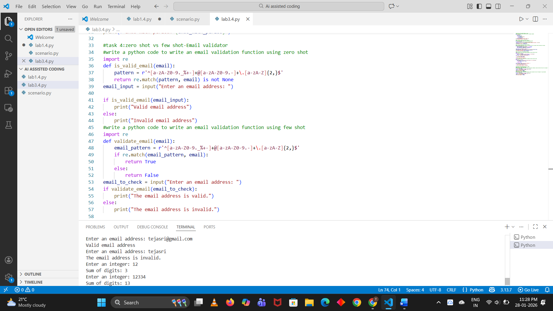

#task5:prompt tuning-summing digits of a number
#Prompt Style 1: Generic Task Prompt
#Write a Python function named sum_of_digits that takes an integer as input and returns the sum of its digits. The function should handle positive integers and return an integer result.
def sum_of_digits(num):
return sum(int(digit) for digit in str(abs(num)))
number = int(input("Enter an integer: "))
result = sum_of_digits(number)
print("Sum of digits:", result)
#Prompt Style 2: Task + Input/Output
#Write a Python function called sum_of_digits(n) that calculates the sum of the digits of a given number
def sum_of_digits(n):
return sum(int(digit) for digit in str(abs(n)))
number = int(input("Enter an integer: "))
result = sum_of_digits(number)
print("Sum of digits:", result)
